HISTORICAL GEOLOGY (GEY121)
Pre-Lab
Name: _____________________________
“Lab #6 Stratigraphic Principles and Age Determinations”

Define the following:

Formation -

Original Horizontality -

Superposition -

Cross-cutting relationships -

Please answer the following:
1. What is the age of a rock that contains Trilobites and Reptiles (aquatic)? Where do the age ranges of these two groups overlap, this is the age (see the fossil age range chart). Please give the name (s) of the time period(s) involved.

2.Determine the sequence of events for the following diagram:
A
G
M
T
Youngest: _____________

_______________

_______________

Oldest _______________

Relative Dating
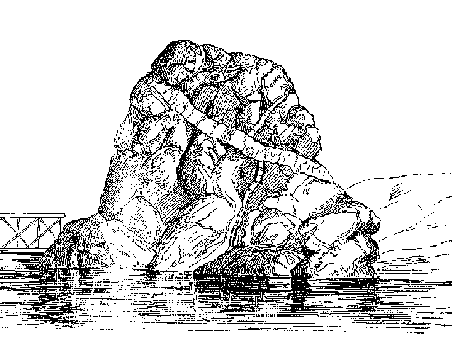
Cross-cutting relationships seen in igneous rock.
Historical Geology Laboratory GEY121

Introduction:
How do geologists determine the age of the earth? What methods are used to decipher the geologic past? One method known as Relative Dating takes the geologic sequence of events into account based on physical evidence.

Determining the general sequence of geologic events of the earth may seem complicated. However, these events can be broken down into basic components and placed in sequence relative to each other. These events can include:

- The deposition of a sandstone layer
- And eruption of lava which will form a lava flow.
- The emplacement of an igneous intrusion.
- Folding of rock layers
- Faulting (displacement) of rock layers.
- Sequences interrupted by erosion: unconformities

Objectives:
Determine the relative ages of geologic events in Diagrams #1-6.

Materials:
This Pre Lab and Laboratory

Procedure:
I.Using the Diagrams #1-4, and 8.9-8.12 provided determine the sequence of geologic events for each diagram. Please, use a pencil, you may change your mind several times!
- For Diagrams #1-4 indicate the type of unconformities present, if any.
- For Diagram Figures 8.9-8.12 indicate unconformities by putting a carrot “<” next to the sequence of events to mark these boundaries.

Take a look at each diagram to determine the sequence of events. HINT: start from the top or bottom, OR do both at once. Either method may work for you. Use the principles given on the handout (these are basically “common sense”).

Place the geologic events in order from oldest event to youngest event. Remember you are now a geologic detective. Use all of the information you can in determining the sequence of events!

II. Answer the “Post Lab” questions provided concerning fossil age ranes, index fossils, and Geologic Time. Determine Geologic Time(s) where these fossils occur together. Please use the name of the Geologic Time Period..
Relative Dating Terms and Concepts

Original Horizontality – Layers are deposited horizontally, these include sedimentary rock and lava flows (ash deposits too!). Simply stated: layers are deposited FLAT.
Layers Flat-Undisturbed
Layers TILTED-disturbed
By uplift!

Superposition - In a sequence of undisturbed sedimentary rock (or lava flows), the oldest rocks are found on the BOTTOM, youngest rocks will be found on the TOP.
Youngest Rocks

Oldest Rocks

Cross-cutting relations - A disrupted/disturbed pattern is OLDER than the cause of the disruption. Simply stated: rock layers are cut across by other geologic events such as FAULTS and/or IGNEOUS INTRUSIONS.
Dike cutting across layers
Layers displaced by a Fault

Unconformity – A sequence of rock layers have been halted by an event which can include EROSION or NO DEPOSITION. These are indicated where:

Flat rocks lay on top of tilted layers
Angular Unconformity

Name: _______________________

Relative Dating Laboratory Worksheets
Determine the sequence of events for Diagrms #1 through 4, 8.9 to 8.12

Diagram #1
Shale
Limestone
Sandstone
Conglomerate
Youngest Event
Last to happen_____________________
_____________________
_____________________
Oldest Event
First to happen_____________________

Limestone
Sandstone
Shale
Basalt

Fault

Youngest Event
Last to happen_____________________
_____________________
_____________________
_____________________
Oldest Event
First to happen_____________________
Diagram #2

Youngest
Last to happen _______________________

____________________

____________________

____________________

____________________

____________________
Oldest
First to happen _______________________

Note: Identify the unconformity.
Schist
Sandstone
Shale
Limestone
Siltstone
Conglomerate
Diagram #3
Unconformity

Youngest
Last to happen _______________________

____________________

____________________

____________________

____________________

____________________

____________________

____________________

____________________

____________________

____________________
Oldest
First to happen _______________________

Note: Identify the 2 unconformities in Diagram #4.
Sandstone
Conglomerate
CHALK
Rock Salt
Red Siltstone
Red Siltstone
GNEISS
Shale
Shale
Green Shale
Basalt
Diagram #4
Fault

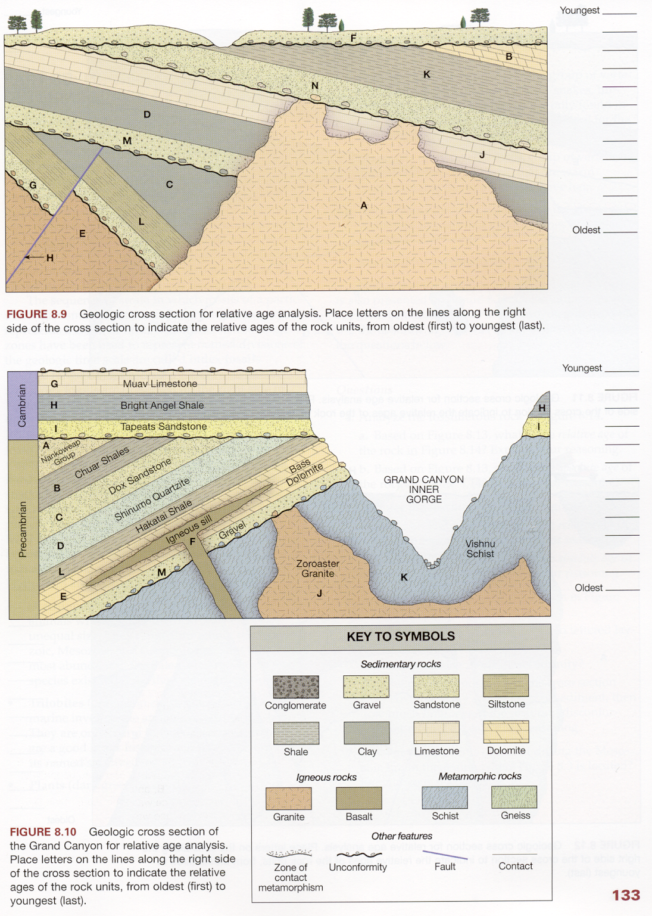
E
G
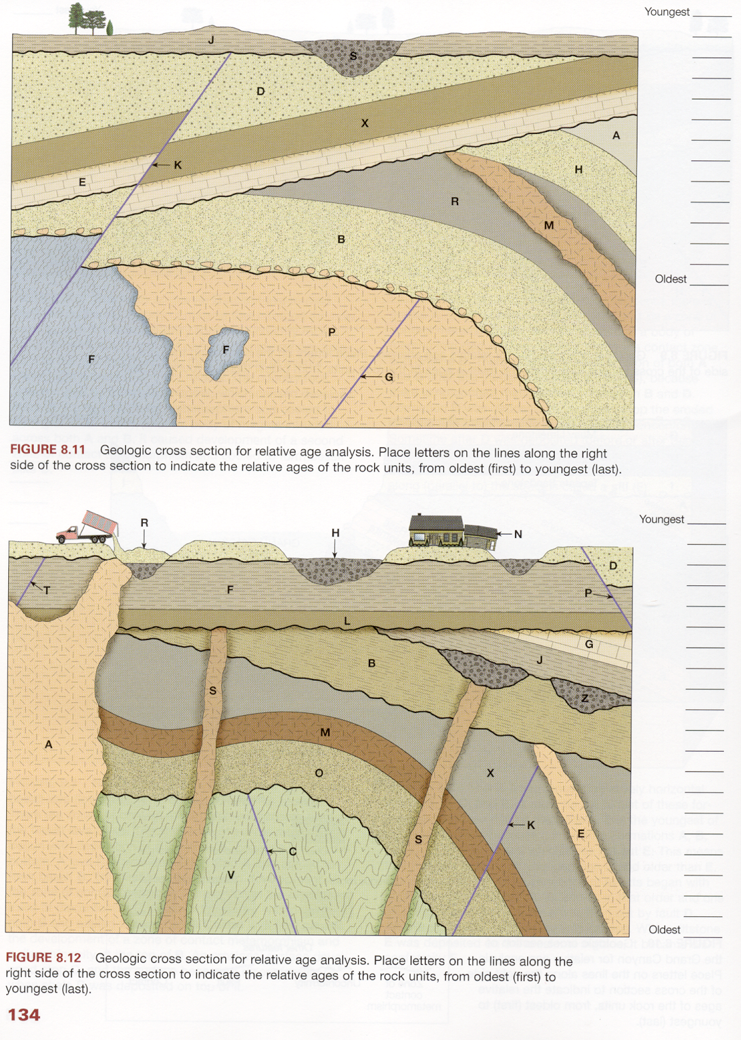
PART II – Post Lab Instructions: Determine the Geologic Age Range possible for each of the following “assemblages” of fossils. Refer to the age range charts found on the last page of this lab. You will determine where the fossil age ranges overlap each other to determine the Geologic Age.

Example: Tabulata (Ordovician to Permian); Graptolite/Graptolithina (Cambrian – Mississippian), these OVERLAP from the Ordovician to Mississippian. So Rocks containing both of these fossils represent this Geologic Age Range.

Permian
Pennsylvanian
Mississippian
Devonian
Silurian
Ordovician
Cambrian
PALEOZOIC

Age Range:
Ordovician to Mississippian

Age Range Overlap

Tabulata
Graptolites

POST LAB (continued)

Please provide the geologic age range for the following fossil assemblages:

- Assemblage 1: Graptolite (Hemichordata), Trilobites, Ammonoids.

- Assemblage 2: Articulate Brachiopods, Pelecypods (bivalves), Bryozoans, Rugose Corals.

- Assemblage 3: Gastropods, Pelecypods, Scleractinian Corals, Fish (Pisces).

- Assemblage 4: Blastoidea, Ammonoidea, Reptile Skull, Tabulate Corals.
Fossil Age Ranges
Phylum/Class/Order Age Range
Porifera Proterozoic to Recent
Cnidaria
- Rugosa Ordovician to Permian
- Scleractinia Triassic to Recent
- Tabulata Ordovician to Permian
Bryozoa Ordovician to Recent
Brachiopoda Cambrian to Recent
Mollusca
- Gastropoda Cambrian to Recent
- Bivalvia (pelecypoda) Cambrian to Recent
- Cephalopoda
  - Ammonoidea Devonian to Cretaceous
  - Nautiloidea Cambrian to Recent
Arthropoda
- Trilobita Cambrian to Permian
- Crustacea
  - Ostracoda Cambrian to Recent
- Insecta (uniramia) Devonian to Recent
Echinodermata
- Crinoidea Cambrian to Recent
- Blastoidea Ordovician to Permian
- Echinoidea Ordovician to Recent

Hemichordata
- Graptolithina Cambrian to Mississippian (Early Carboniferous)

Chordata
- Vertebrata
  - Pisces (fish) Ordovician to Recent
  - Amphibia Devonian to Recent
  - Reptilia Pennsylvanian (Late Carboniferous) to Recent
  - Mammalia Triassic to Recent
  - Aves Jurassic to Recent
GEOLOGIC TIME SCALE
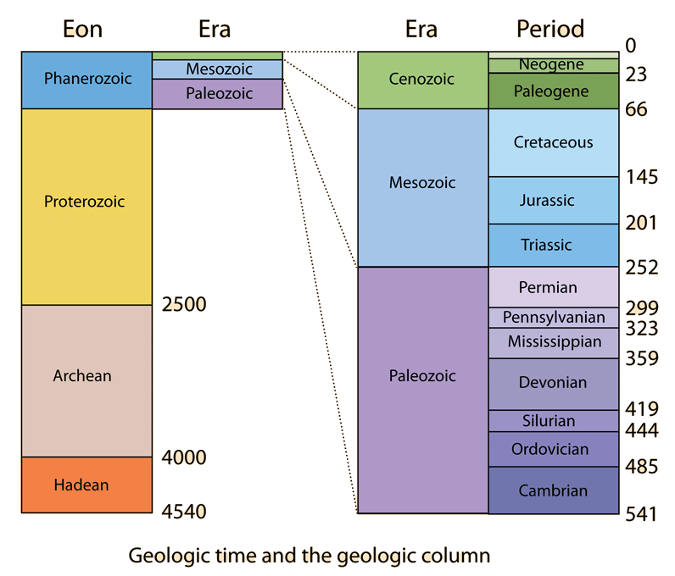

Geologic Time Matrix - Optional
For Determining the Stratigraphic Ranges of Fossil Groups – Provided for use with Post Lab.
EON | ERA | PERIOD | Organism Range
Phanerozoic | Cenozoic | "Recent"
 |  | Quaternary
 |  | Tertiary
 | Mesozoic | Cretaceous
 |  | Jurassic
 |  | Triassic
 | Paleozoic | Permian
 |  | Pennsylvanian
 |  | Mississippian
 |  | Devonian
 |  | Silurian
 |  | Ordovician
 |  | Cambrian
Precambrian |  | Proterozoic
 |  | Archean
 |  | Hadean
 |  |  | __________________________ | __________________________ | __________________________ | __________________________ | __________________________ | __________________________ | __________________________ | __________________________ | __________________________ | __________________________
 |  |  | Phylum/Class/Order | Phylum/Class/Order | Phylum/Class/Order | Phylum/Class/Order | Phylum/Class/Order | Phylum/Class/Order | Phylum/Class/Order | Phylum/Class/Order | Phylum/Class/Order | Phylum/Class/Order

